Ray Defined by a Point and Direction
# Source: AI Source: Provided by: [Data Path: Persons Table -> ID Column: 1, Name_En Column: Motasem Essam] -> From: [ChatGPT] on [7/25/2026]
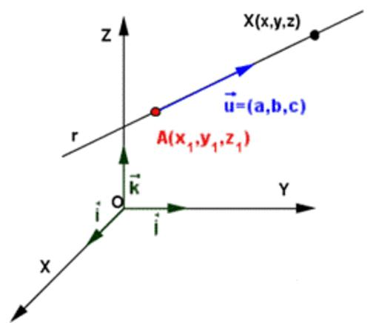
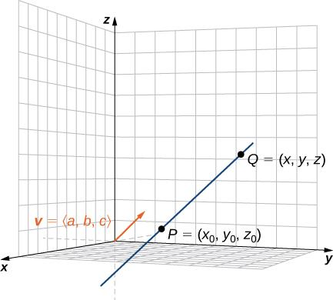
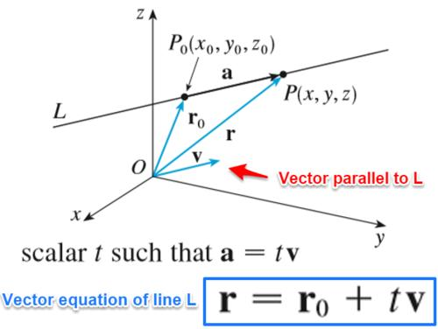

Definition
# Source: AI Source: Provided by: [Data Path: Persons Table -> ID Column: 1, Name_En Column: Motasem Essam] -> From: [ChatGPT] on [7/25/2026]
A ray defined by a point and direction is a geometric ray in three-dimensional space specified by an initial point and a direction in which it extends indefinitely.
The initial point determines where the ray begins, while the direction determines the path it follows. The ray continues infinitely in that direction but does not extend backward beyond its initial point.
A ray can be represented using a point $A$ and a nonzero direction vector $v$.
If $A=\left(x_{0},y_{0},z_{0}\right)$ and $v=\left(a,b,c\right)$, then the ray is represented parametrically by
$$r\left(t\right)=A+tv, t≥0$$
where:
- $A$ is the position vector of the initial point.
- $v$ is the direction vector, which must not be the zero vector.
- $t$ is a real parameter satisfying $t≥0$.
- $t=0$ gives the initial point.
- $t>0$ gives points farther along the ray in the specified direction.

Simple definition
# Source: AI Source: Provided by: [Data Path: Persons Table -> ID Column: 1, Name_En Column: Motasem Essam] -> From: [ChatGPT] on [7/25/2026]
A ray defined by a point and direction is a ray that starts at a specified point and extends endlessly in a specified direction.
For example, a ray may start at $A=\left(1,2,3\right)$ and extend in the direction $\left(2,1,0\right)$. It begins at $A$ and continues parallel to the vector $\left(2,1,0\right)$, without extending backward.

Key characteristics
# Source: AI Source: Provided by: [Data Path: Persons Table -> ID Column: 1, Name_En Column: Motasem Essam] -> From: [ChatGPT] on [7/25/2026]
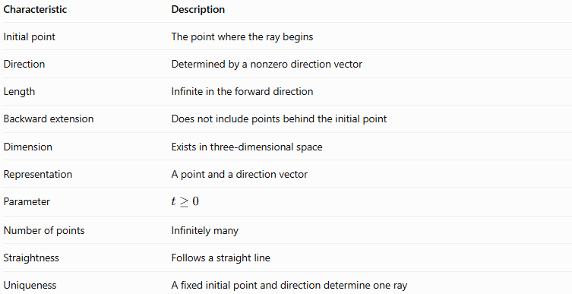
Characteristic | Description
Initial point | The point where the ray begins
Direction | Determined by a nonzero direction vector
Length | Infinite in the forward direction
Backward extension | Does not include points behind the initial point
Dimension | Exists in three-dimensional space
Representation | A point and a direction vector
Parameter | $$t≥0$$
Number of points | Infinitely many
Straightness | Follows a straight line
Uniqueness | A fixed initial point and direction determine one ray

Geometric representation
# Source: AI Source: Provided by: [Data Path: Persons Table -> ID Column: 1, Name_En Column: Motasem Essam] -> From: [ChatGPT] on [7/25/2026]
A ray defined by a point and direction can be visualized as an arrow that starts at a fixed point and continues in one direction.
For example, consider the initial point $A=\left(1,2,3\right)$ and the direction vector $v=\left(2,1,0\right)$.
Illustrative coordinate diagram
Schematic illustration only; the ray's arrow indicates its direction of extension.
The ray begins at $A$. Its direction vector determines how the coordinates change as the ray progresses.

Mathematical representation

Vector equation
# Source: AI Source: Provided by: [Data Path: Persons Table -> ID Column: 1, Name_En Column: Motasem Essam] -> From: [ChatGPT] on [7/25/2026]
The standard vector equation is
$$\boxed{r\left(t\right)=A+tv, t≥0}$$
Suppose the initial point is $A=\left(x_{0},y_{0},z_{0}\right)$ and the direction vector is $\left(a,b,c\right)$. Then
$$\begin{aligned}x&=x_{0}+at \\ y&=y_{0}+bt \\ z&=z_{0}+ct, t≥0\end{aligned}$$
These equations describe every point on the ray.

Set notation
# Source: AI Source: Provided by: [Data Path: Persons Table -> ID Column: 1, Name_En Column: Motasem Essam] -> From: [ChatGPT] on [7/25/2026]
The ray can also be expressed as a set of points:
$$\boxed{R=\left\{A+tv∣t≥0\right\}}$$
This means that the ray consists of all points obtained by starting at $A$ and adding a nonnegative multiple of the direction vector.

Relationship to two-point notation
# Source: AI Source: Provided by: [Data Path: Persons Table -> ID Column: 1, Name_En Column: Motasem Essam] -> From: [ChatGPT] on [7/25/2026]
If $A$ is the initial point and $B$ is another point in the direction of the ray, then the direction vector can be calculated as
$$\overset{→}{AB}=B-A$$
The ray can consequently be written as
$$\boxed{R=\left\{A+t\left(B-A\right)∣t≥0\right\}}$$
The conventional geometric notation is $\overset{→}{AB}$, where $A$ is the endpoint and $B$ indicates the direction.

Worked examples
# Source: AI Source: Provided by: [Data Path: Persons Table -> ID Column: 1, Name_En Column: Motasem Essam] -> From: [ChatGPT] on [7/25/2026]
Example 1: Constructing a ray from a point and direction
Problem: Define a ray starting at $A=\left(1,2,3\right)$ with direction vector $v=\left(2,1,0\right)$.
Solution:
Use the vector equation:
$$r\left(t\right)=A+tv, t≥0$$
Substitute the given values:
$$r\left(t\right)=\left(1,2,3\right)+t\left(2,1,0\right)$$
Therefore,
$$\boxed{\begin{aligned}x&=1+2t \\ y&=2+t \\ z&=3, t≥0\end{aligned}}$$
The ray starts at $\left(1,2,3\right)$ and extends indefinitely while remaining at $z=3$.
Example 2: Finding points on the ray
Problem: Find three points on the ray
$$r\left(t\right)=\left(2,1,4\right)+t\left(1,2,3\right), t≥0$$
Solution:
Choose nonnegative values of $t$.
- For $t=0$:
$$P_{0}=\left(2,1,4\right)$$
- For $t=1$:
$$P_{1}=\left(2,1,4\right)+\left(1,2,3\right)=\left(3,3,7\right)$$
- For $t=2$:
$$P_{2}=\left(2,1,4\right)+2\left(1,2,3\right)=\left(4,5,10\right)$$
The three points are $\left(2,1,4\right)$, $\left(3,3,7\right)$, and $\left(4,5,10\right)$. All lie on the ray in the specified direction.
Example 3: Determining whether a point lies on the ray
Problem: Does $P=\left(5,7,10\right)$ lie on the ray
$$r\left(t\right)=\left(2,1,4\right)+t\left(1,2,3\right), t≥0?$$
Solution:
Compare the coordinates:
$$\begin{aligned}2+t&=5&&⇒t=3 \\ 1+2t&=7&&⇒t=3 \\ 4+3t&=10&&⇒t=2\end{aligned}$$
The values of $t$ are inconsistent. Therefore,
$$\boxed{P\text{ does not lie on the ray.}}$$
A point belongs to the ray only when the same nonnegative parameter satisfies all three coordinate equations.
Example 4: Distinguishing the ray from its full line
Problem: Consider the ray
$$r\left(t\right)=\left(1,2,3\right)+t\left(2,0,0\right), t≥0$$
Determine whether $P=\left(-3,2,3\right)$ lies on the ray.
Solution:
Using the $x$-coordinate:
$$1+2t=-3$$
$$t=-2$$
Since $t=-2$ is negative, the point is behind the initial point and is not part of the ray.
$$\boxed{P\text{ lies on the full line, but not on the ray.}}$$

Comparison with related geometric concepts
# Source: AI Source: Provided by: [Data Path: Persons Table -> ID Column: 1, Name_En Column: Motasem Essam] -> From: [ChatGPT] on [7/25/2026]
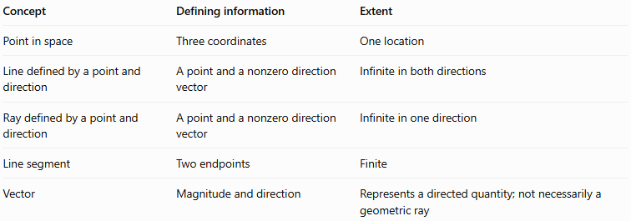
Concept | Defining information | Extent
Point in space | Three coordinates | One location
Line defined by a point and direction | A point and a nonzero direction vector | Infinite in both directions
Ray defined by a point and direction | A point and a nonzero direction vector | Infinite in one direction
Line segment | Two endpoints | Finite
Vector | Magnitude and direction | Represents a directed quantity; not necessarily a geometric ray
The key distinction is the parameter restriction: a line allows $t∈R$, whereas a ray starting at $A$ allows only $t≥0$.

Applications
# Source: AI Source: Provided by: [Data Path: Persons Table -> ID Column: 1, Name_En Column: Motasem Essam] -> From: [ChatGPT] on [7/25/2026]
- Three-dimensional geometry: Describing rays that originate at specified points in space.
- Computer graphics: Representing viewing rays and tracing paths from a camera into a scene.
- Physics: Modeling idealized paths of light or other directed propagation.
- Intersection problems: Determining whether a ray meets a plane, surface, or solid.
- Coordinate geometry: Testing whether a point lies on a ray and finding its position along that ray.
- Navigation and simulation: Representing movement or travel from an initial location in a fixed direction.

Key points
# Source: AI Source: Provided by: [Data Path: Persons Table -> ID Column: 1, Name_En Column: Motasem Essam] -> From: [ChatGPT] on [7/25/2026]
- A ray defined by a point and direction requires an initial point and a nonzero direction vector.
- The ray begins at its initial point and extends indefinitely in one direction.
- Its parametric equation is $r\left(t\right)=A+tv$, with $t≥0$.
- The initial point is included because $t=0$ is allowed.
- Negative values of $t$ describe points on the same full line but behind the ray's initial point.
- The direction vector determines orientation, not necessarily a unit length.
- Different nonzero direction vectors that are positive scalar multiples of one another define the same ray when they share the same initial point.

Conclusion
# Source: AI Source: Provided by: [Data Path: Persons Table -> ID Column: 1, Name_En Column: Motasem Essam] -> From: [ChatGPT] on [7/25/2026]
A ray defined by a point and direction is a fundamental object in solid geometry. It provides a precise way to describe a straight path beginning at a known point and extending endlessly in a specified direction. Its vector and parametric representations make it useful for coordinate calculations, spatial intersections, and three-dimensional modeling.

